**Power BI Visualization Explanation and Complete Analysis**

**Created the 3 Dashboard in power BI**

**Dashboard 1:** 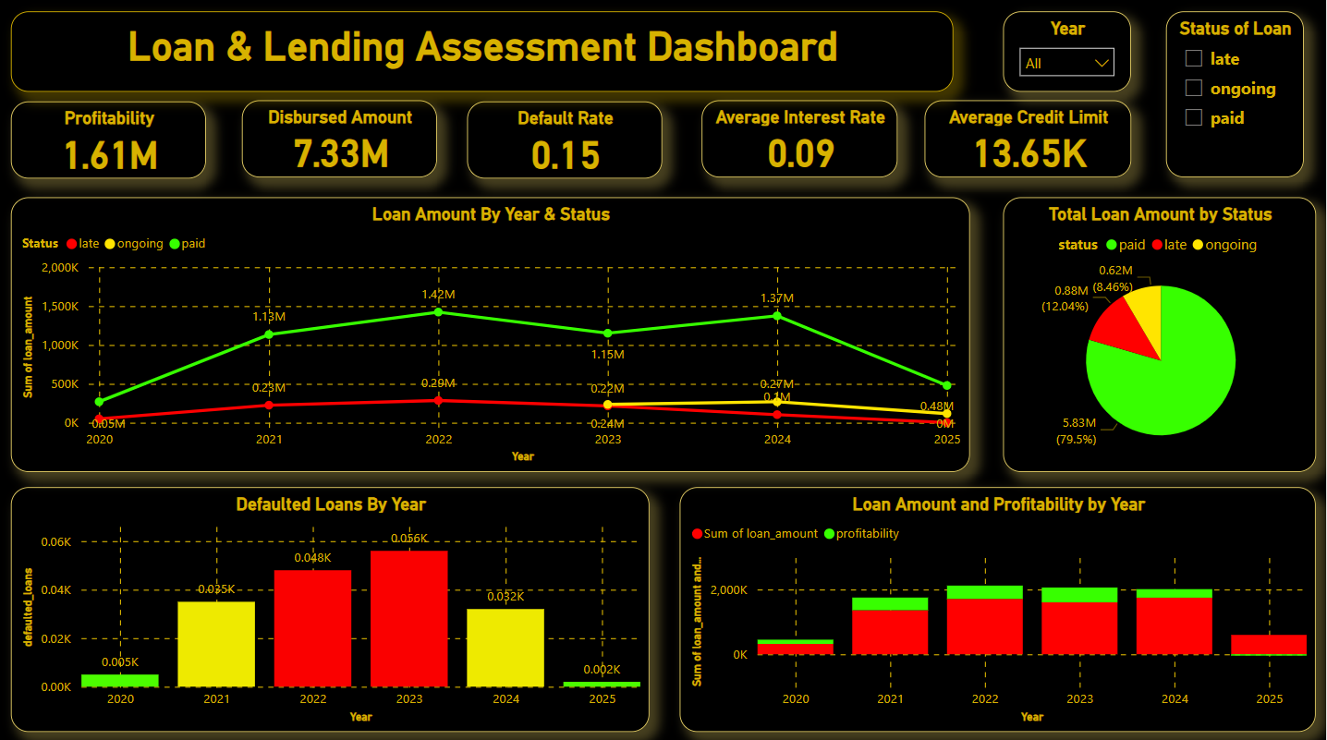

**Calculated Measures I have created:**

* Average Credit Limit = AVERAGE(users[credit_limit])
* Average Interest Rate = AVERAGE(users[interest_rate])
* AvgLoanByIntensity = CALCULATE(AVERAGE(loans[loan_amount]), VALUE(emotional_data[intensity]))
* AvgLoanByScore = CALCULATE(AVERAGE(Loans[loan_amount]),VALUES(users[score]))
* AvyLoanByCreditLimit = CALCULATE(AVERAGE(loans[loan_amount]), VALUES(users[credit_limit]))
* Default Rate = DIVIDE(COUNTROWS(FILTER(loans, loans[status] = "late")),COUNTROWS(loans),0)
* default_percentage = DIVIDE([defaulted_loans], COUNT('loans'[loan_id]), 0)
* defaulted_loans = COUNTROWS(FILTER('loans', loans[status] = "late"))
* profitability = SUM(loans[loan_amount_paid]) - SUM(loans[loan_amount])
* Total Disbursed = SUM(loans[loan_amount])

The Dashboard focuses on assessing the performance of loans and lending operations, featuring several key metrics (KPIs) and visualizations that highlight profitability, loan disbursement, default rates, and overall loan performance by status and year. Let’s break down the KPIs and charts one by one:

**KPIs (Top Row):**

1. **Profitability (1.61M)**:
   * This metric represents the total **profit** generated from the lending operation, likely calculated as the difference between the interest earned and the cost incurred (such as loan defaults or operational costs).
2. **Disbursed Amount (7.33M)**:
   * This value shows the **total amount** of loans that have been disbursed to borrowers over time, indicating the overall scale of the lending operation.
3. **Default Rate (0.15)**:
   * The **default rate** shows the proportion of loans that have not been repaid as scheduled. A rate of 0.15 suggests that 15% of loans have defaulted.
4. **Average Interest Rate (0.09)**:
   * This is the **mean interest rate** charged across all loans, a key factor in determining profitability and the cost of borrowing for clients.
5. **Average Credit Limit (13.65K)**:
   * This KPI indicates the **average credit limit** granted to borrowers, providing insights into how much the institution is willing to lend on average.

**Filters (Top-Right):**

* **Year**:
  + A filter that allows users to view data for specific years or across all years.
* **Status of Loan**:
  + This filter enables users to focus on loans based on their status: **late**, **ongoing**, or **paid**.

**Graphs:**

**1. Loan Amount By Year & Status (Line Chart):**

* **X-axis (Year)**: Shows the year from 2020 to 2025.
* **Y-axis (Sum of Loan Amount)**: Shows the total loan amount disbursed per year.
* **Lines:**
  + **Green Line (Paid)**: Represents loans that have been successfully repaid.
  + **Yellow Line (Ongoing)**: Shows the amount for loans that are still ongoing or in progress.
  + **Red Line (Late)**: Displays the sum of loans that are overdue or late in payment.
* **Insights**: The graph shows a peak in loan amounts around 2022, followed by a decline in subsequent years. The loans marked as "late" remain relatively low but consistent, while the ongoing and paid loans fluctuate across the years.

**2. Total Loan Amount by Status (Pie Chart):**

* This pie chart breaks down the **total loan amount** by loan status (paid, late, ongoing).
* **Green (Paid - 79.5%)**: Represents the largest portion of loans, indicating that most loans have been repaid.
* **Red (Late - 12.04%)**: Represents loans that are overdue, making up a smaller portion.
* **Yellow (Ongoing - 8.46%)**: Represents loans that are currently in progress or yet to be completed.

**3. Defaulted Loans By Year (Bar Chart):**

* **X-axis (Year)**: Displays the year from 2020 to 2025.
* **Y-axis (Defaulted Loans)**: Shows the number of loans that defaulted.
* **Bars**:
  + **Green Bar (2020)**: Shows low defaults early on.
  + **Red Bars (2021-2023)**: Peaks in defaults can be seen around 2022 and 2023.
  + **Yellow Bars (2024-2025)**: Indicates that defaults decrease in 2024 and almost disappear in 2025.

**4. Loan Amount and Profitability by Year (Bar Chart):**

* **X-axis (Year)**: Displays the year from 2020 to 2025.
* **Y-axis (Sum of Loan Amount and Profitability)**: Shows both the total loan amount and profitability over the years.
* **Bars**:
  + **Red Bars**: Represents the **sum of the loan amount** disbursed in each year.
  + **Green Bars**: Represents the **profitability** generated for each year.
* **Insights**: Profitability fluctuates in relation to the loan amounts, showing a peak in 2023, followed by a drop in both profitability and loan amounts in 2025.

**Slicers:**

* **Loan Status Slicer**: Allows you to filter the data by All, late, ongoing, or paid loans.
* **Year Slicer**: Filters the data by selecting specific years, allowing you to focus on a particular time period.

These slicers are helpful for narrowing down data and analyzing specific aspects of the loan trends and performance based on the selected criteria.

**Summary of Insights:**

* **Profitability and Loan Disbursement**: Profitability reached a high of 1.61M, with a disbursed loan amount of 7.33M. Loan disbursement peaked in 2022.
* **Default Rates**: The default rate stands at 0.15, peaking in 2023 but improving in 2025 as defaults decrease.
* **Status of Loans**: Most loans are repaid (79.5%), while 12.04% are late. Ongoing loans make up 8.46%.
* **Trends in Loan Amounts and Profitability**: Profitability follows the trends of loan amounts, rising as disbursements increase and falling with declining loan amounts.

The dashboard provides a clear view of the lending operation's performance over time, emphasizing key metrics like profitability, default rates, and loan statuses, while offering flexibility through filters for more targeted analysis.

**Dashboard 2:**

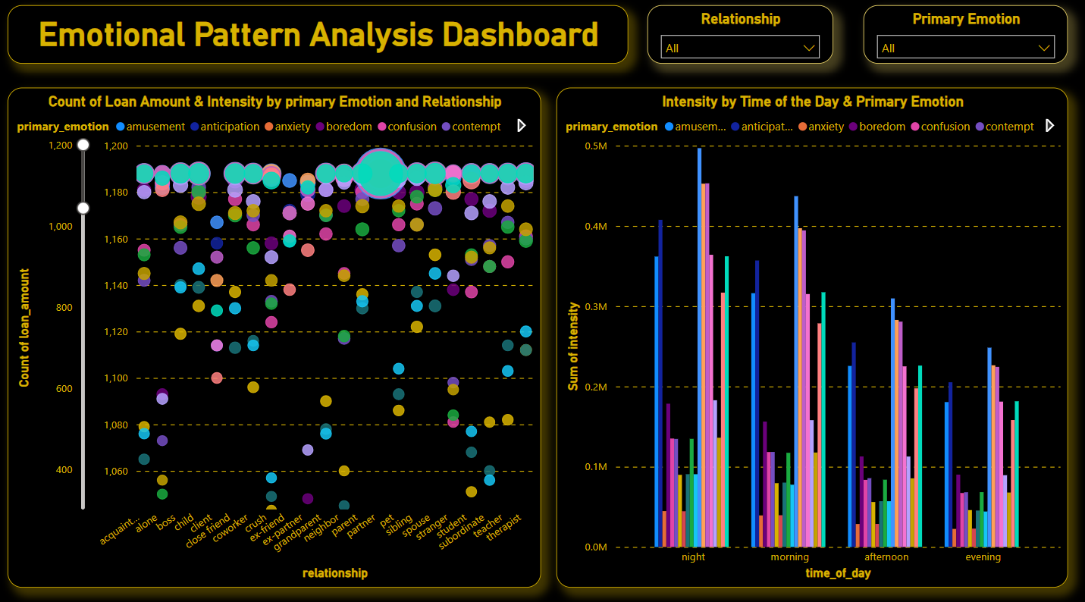

**Count of Loan Amount & Intensity by Primary Emotion and Relationship**

* **Bubble Chart**:
  + **X-axis (relationship)**: This axis represents different types of relationships such as partner, friend, sibling, etc.
  + **Y-axis (loan_amount)**: It shows the count of loan amounts, indicating how frequently loans of certain amounts were observed in the data.
  + **Bubble Size (intensity)**: The size of the bubbles corresponds to the intensity of the emotion during the loan interaction.
  + **Colors (primary_emotion)**: Each color represents a different primary emotion (e.g., amusement, anxiety, anticipation), making it easy to compare emotional contexts across relationships.
  + **Purpose**: This graph helps in understanding how loan amounts and emotional intensity vary depending on relationships and emotions. You can visually see if certain relationships are associated with higher loan amounts or emotional intensities.

**Right Graph: Intensity by Time of Day & Primary Emotion**

* **Bar Chart**:
  + **X-axis (time_of_day)**: This axis is segmented into different parts of the day (night, morning, afternoon, evening).
  + **Y-axis (Sum of intensity)**: The total sum of emotional intensity is displayed for each part of the day.
  + **Colors (primary_emotion)**: As with the bubble chart, each color here corresponds to a primary emotion, allowing a comparison of how emotions fluctuate throughout the day.
  + **Purpose**: This bar chart shows the correlation between emotional intensity and the time of day. You can observe when emotional intensity is highest for different emotions, which could reveal patterns such as heightened anxiety in the evening or increased amusement in the morning.

**Slicers:**

* **Relationship Slicer**: Allows the user to filter the data based on specific relationships (e.g., partner, parent, coworker). This is useful if you want to narrow down the data to see how emotions and loan amounts behave for a particular relationship type.
* **Primary Emotion Slicer**: Lets you filter the visualizations by specific emotions (e.g., anxiety, amusement). By selecting an emotion, you can focus on how this emotion interacts with loan amounts, relationships, and times of day.

**Overall Design:**

* The black background with neon-colored lines, bubbles, and bars creates a visually striking look, enhancing the clarity of different emotions and relationships across the graphs.
* The **interactive slicers** make it easy to explore specific emotional and relational patterns dynamically, providing a customizable view for decision-making.

This dashboard provides insights into how loan amounts and emotional intensity change across different contexts, including relationship types and time of day, while also allowing for further exploration through the slicers.

**Dashboard 3:**

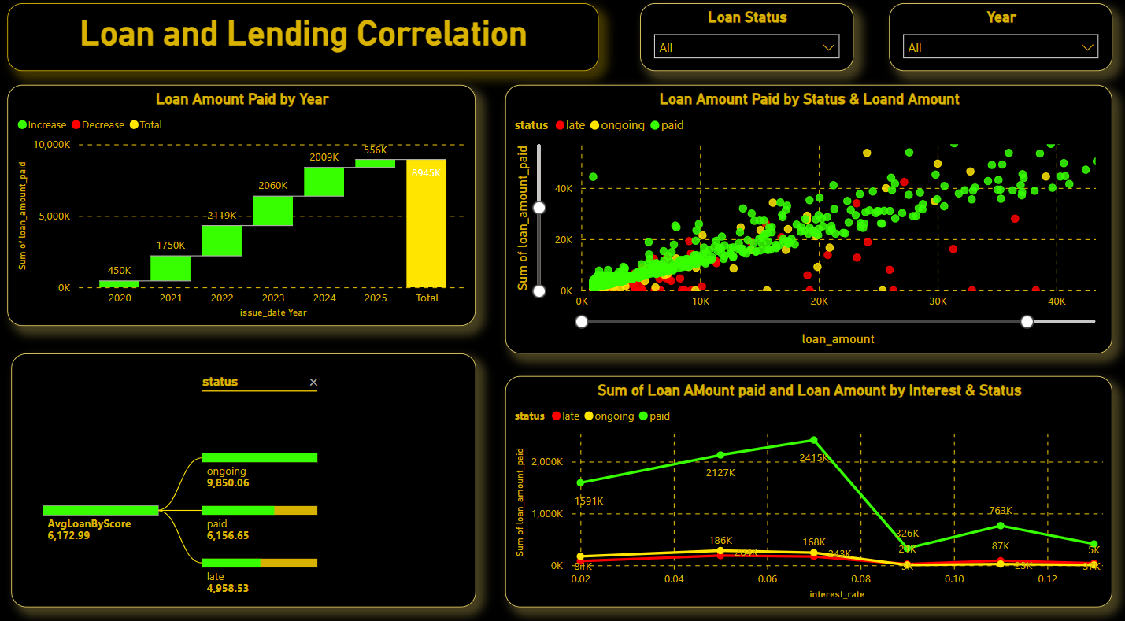

**Graphs:**

1. **Loan Amount Paid by Year (Top Left)**
   * This bar chart displays the total loan amount paid over different years.
   * The green bar indicates an increase in loan amounts paid, while the red bar indicates a decrease. The yellow bar shows the total.
   * The chart helps identify trends over the years, such as the increase in loan amounts from 2020 to 2025.
2. **Loan Amount Paid by Status & Loan Amount (Top Right)**
   * This scatter plot shows the relationship between loan amounts and loan amounts paid, categorized by the status (late, ongoing, paid).
   * Green, yellow, and red colors are used to represent paid, ongoing, and late loans, respectively.
   * This graph helps understand how different loan statuses vary with the loan amount, providing insight into payment behaviors.
3. **AvgLoanByScore by Status (Bottom Left)**
   * This Sankey chart shows the average loan amount by different statuses (ongoing, paid, late).
   * It helps illustrate how the average loan amount is distributed across different loan statuses.
   * The values provide an idea of which status tends to have higher average loan amounts.
4. **Sum of Loan Amount Paid by Interest & Status (Bottom Right)**
   * This line chart shows the sum of the loan amount paid in relation to interest rates, with different lines for each status (late, ongoing, paid).
   * It helps identify trends on how interest rates affect loan payments and the associated loan status.
   * For example, it shows how the paid loan amounts peak at certain interest rates compared to late or ongoing statuses.

**Slicers:**

* **Loan Status Slicer**: Allows you to filter the data by All, late, ongoing, or paid loans.
* **Year Slicer**: Filters the data by selecting specific years, allowing you to focus on a particular time period.

These slicers are helpful for narrowing down data and analyzing specific aspects of the loan trends and performance based on the selected criteria.